FBLA

Brazil
Report by Shelby Shupe

Table of Contents
Facts About Country…………………………………………………………………...……Page 3

Population…………………………………………………………………………...Page 3
Demographics……………………………………………………………………….Page 3
Geographic Location……………………………………………………………..….Page 4
Government…………………………………………………………………….……Page 4

Economic Facts…………………………………………………………………………...…Page 4

Economic System……………………………………………………………...…….Page 4
Exports………………………………………………………………………………Page 4
Currency………………………………………………………………………….….Page 5

Travel Information…………………………………………………………………………..Page 5

Plan Tickets………………………………………………………………………….Page 5
Documentation……………………………………………………………………....Page 5
Precautions…………………………………………………………………………..Page 5
Methods of Transportation…………………………………………………………..Page 6
Hotels………………………………………………………………………………..Page 7

Culture and Customs………………………………………………………………………...Page 7
Holidays……………………………………………………………………….…….Page 7
Customs……………………………………………………………………………..Page 9
Etiquette………………………………………………………………………….….Page 9
Business Relations…………………………………………………………….…...Page 10

Eating Habits…………………………………………………………………………….....Page 11

Food………………………………………………………………………………..Page 11
Mealtime Customs……………………………………………………………..…..Page 11

FBLA…………………………………………………………………….…………………Page 12

FBLA……………………………………………………………………………….Page 12
FBLA Website……………………………………………………………..………Page 12
Social Media………………………………………………………….…….………Page 12
FBLA Conferences………………………………………………………...……….Page 13

Budget…………………………………………………………………………………...…Page 13

Estimate………………………………………………………………………..…...Page 13

Appendices………………………………………………………………...……………Page 14-22

BRAZIL

Facts About the Country
Population: The overall population of Brazil, from an estimate in July 2014, is 202,656,788 people. The growth rate of the population is about 0.8% each year. The birth rate per year is 14.72 births for every 1000 people, and the death rate is 6.54 deaths for every 1000 people per year.
Demographics: The age of the Brazilian population varies greatly. The average age for a male is 29.9 years, and a female is 31.5 years. 23.8% of the population is 14 years of age or younger. 16.5% of the population is 15-24. There is 43.7% of the people that are 25-54. 8.4% are 55-64. Only 7.6% are older than 65.

Geographic Location: Brazil is the biggest country in South America. It borders every other country on the continent except Ecuador and Chile. Its eastern border touches the Atlantic Ocean.
Government: Brazil is composed of 26 states. In 1996, all of the states got divided into more than 5,500 municipalities. The president of the country is elected directly by the people, with a Congress elected based on the interests of the different regions. While the bicameral Congress has had growing influence over the most recent years, the president still holds a lot more authority over the country. The judiciary is independent of both the other branches and holds a comfortable amount of authority. Even though they are somewhat unbalanced, the three branches normally agree and work well together, with only some exceptions being the difference.
Economic Facts
Economic System: Brazil has good exports, lots of mining, and a rapidly expanding middle class, which makes it the wealthiest country in South America. The country’s unemployment rates are currently low, though they were high during the recession in 2008 that affected the world.
Exports: Brazil has twelve main exports: sugar, coffee, orange juice, beef, poultry, soybeans, corn, cocoa, timber, cotton, tobacco, and ethanol. It leads the world in the production of sugar, coffee, orange juice, beef, tobacco, and ethanol. Poultry is quite new to the country, but quickly growing. It’s the world’s number two producer of soybeans and the number three producer of corn. It is number six in cocoa growers, and ranks number four in cotton. Brazil’s timber has the lowest cost in the world to buy, because of the abundant rain, sun and land in the tropics that make it so easy to produce.
Currency: The currency in Brazil is the “real”, which is pronounced ray-all. The plural form of the word is “reais” (ray-eyes). The way to write this is R$. Right now, the Real is very strong against a US dollar or a Euro, with one US dollar equaling 2.62 reais.
Travel Information
Plane Tickets: My ticket from Cheap-o-Air is $1,602.72. It is round-trip and leaves on April 19 from Phoenix airport. I will start by flying US Airways to Mexico City, where I have a layover and will move to an Aeromexico plane. From there, I will fly all the way to Sao Paolo, where I will transfer to a plane that will take me into Rio de Janeiro. The return trip only has one layover in Mexico City before it return to Phoenix. With the layover times included, the departure and return trips will both take about 23 hours.
Documentation: The only documentation that Brazil requires to enter the country is a valid US passport and a visa. You have to obtain the Brazilian visa in advance from the Brazilian Embassy or the consulate nearest to you in the United States. When you get to Brazil, they have you fill out an immigration form that they stamp and give back to you. It is important to keep track of the document, as it will be required at the airport for you to leave the country. If you do lose the form, you have to get clearance from the Brazilian Federal Police to leave and there’s a good chance you will have to pay a fine.
Precautions: It is common in the urban areas of Brazil to have labor strikes, which may disrupt transportation. While none of the protests have been aimed at US citizens, it isn’t uncommon for the protests to include vandalism on United States government buildings. While most protests don’t get violent, there is always a small chance that they will. So it is advised that US citizens use common sense and stay away from crowds that are gathered to protest.
Because criminal entities and drug traffickers operate along the Brazilian border, American citizens are told to be careful along the borders of the country. There is also a small chance that while you are along the borders of other countries, you will run into Columbian terrorist groups. There is no known specific threat to US citizens, but the groups have kidnapped tourists along the Columbian border. Exercise caution when you are going to remote locations around that border, and be careful also if visiting the Amazon.
The Brazilian murder rate is four times as high as that in the United States. Street crime is a very common problem for visitors, and US citizens are often targets, especially in the biggest cities. While street crime normally occurs at night, it does happen during the day also. You should carry only a copy of your passport with you and leave the real one somewhere more secure, just in case. Robberies outside of banks and ATMs occur regularly, and be extra careful to avoid being carjacked as that is a viable threat. In public, dress down and avoid carrying anything valuable or wearing expensive watches or jewelry. Pick-pockets are prevalent in Brazil, and dressing up makes you an easier target.
Often times, the people who are offering to help you are actually scamming you. It is called a “Good Samaritan” scam, and it is common for tourists. While Brazil is a great country, the crime is high, and caution should be exercised.
Methods of Transportation: Paved roads are in all of the major cities and connect them together. It is easy to catch a bus in whatever city that you are currently in and take it over the entire country. Another mode of transportation available is sea transport. This type of transportation is most commonly used for entertainment, as it is slower and more expensive than a bus. The last is air travel, which is becoming increasingly popular for trips across the country due to the large size. There are now ten international airports, and all are comfortable and efficient.
There are tips for safety on the road, including the fact that road conditions are very different from those in the United States. The roads are very dangerous because of poor driving skills, bad roads, and a high density of trucks. Brazil requires the use of seatbelts for everyone in the car. Speed limits are widely ignored and rarely enforced, though more and more towns are getting photographic devices in them to take pictures of license plates. Because people speed so often, they tend to brake suddenly when encountering these devices. Cities are also making speed bumps, and often they aren’t even painted, making them hard to see. The Brazilians also have very strict driving under the influence laws. This means that they have checkpoints in cities where they pull over random drivers to take breathalyzer tests. If you are caught at one of these checkpoints, it doesn’t necessarily mean that you are in trouble, you’re just the one that was picked.
Hotels: There are many options for hotels in Brazil, with a three star averaging at $137 per night in Rio de Janeiro. I chose to book a hotel from Expedia. The hotel is called Pompeu Rio Hotel, and for a small room with a single bed, free breakfast, and free internet, it will cost me $45 per night.
Culture and Customs
Holidays: Brazilian holidays are always a huge event, and there are quite a few throughout the year. Some are only celebrated in certain regions of the country, while others are celebrated by everyone. But every holiday is very important to the Brazilian culture.
The first holiday that is celebrated is New Year’s Day. Just like America, it starts the night before and continues on into the next day. This holiday has many celebrations throughout the country, with every major city doing something to celebrate.
The most famous Brazilian holiday is Carnival. It is celebrated during February, before Lent begins. There are parades and street carnivals, and everyone is dressed up in extravagant costumes that are known world-wide. The holiday itself last for four days, and is the most popular among the residential people of Brazil.
Another major holiday is the Anniversary of the Death of Tiradentes. Tiradentes was a national hero in Brazil. He was a revolutionary who fought for the independence of the Brazilian people from their mother country Portugal. Even though gold had been coming in shorter and shorter supply in Brazil, Portugal was still taxing Brazil heavily to make an income off of the colony. Tiradentes came up with a plan for a group of people to refuse paying taxes on the day they were due, but the plan was given away. He was arrested and put on trial. When he was put before the jury, he admitted to starting the plan, and he was hanged on April 21. As the revolution continued and was won, the Brazilian people kept Tiradentes in mind. The people now celebrate a major holiday in his honor on April 21, the day he became a martyr.
May has two holidays in it that are similar to the ones we have in America. The first of May is Labor Day, which is a holiday that usually means no work for most. The second is Mother’s Day, celebrated the second Sunday of May.
The next holiday is a Catholic holiday that is celebrated around the world. Corpus Christi celebrates the body of Christ. Brazil has a huge mass of people that celebrate it, with all of the churches filling up with people who want to pray. While this holiday moves around, it is almost always celebrated in either June or July.
Independence Day in Brazil is September 7. This was the day that Brazil finally gained its independence from Portugal. It is one of the most proud holidays that the Brazilian people have, similar to America’s Independence Day.
On October 12, Brazil celebrates the Children’s Holiday. Children usually have no school on this day, and they receive gifts from their parents. In addition, there are fiestas thrown all over the country.
On November 2, the country celebrates the Day of the Dead. This holiday is celebrated throughout Christian countries around the world. People recognize it by taking things such as candles and flowers to the cemeteries. Another holiday in November is Republic Day, which is when the birth of the Brazilian Republic was.
Customs: Brazil has a class system, usually on a racial basis. Generally, those with darker skin color are disadvantaged. The upper and middle classes also have very limited interaction with those of lower classes than themselves. The different classes have quite a difference in their salaries, which makes their lifestyles very different in turn. And although women make up 40% of the workforce, they are most often in the lower class.
Brazilians put an incredible amount of stock in their families. The families are usually large, although they’ve been getting smaller as recent years have passed, and extended families are usually just as close as immediate families. Family members that own businesses are encouraged to act on nepotism, as it is considered a good thing to hire people that you know and trust.
Etiquette: When men are greeting one another, they shake hands and maintain steady eye contact. When a woman greets another woman, it’s normal for them to kiss each other’s cheeks, starting with the left and then going to the right. Once Brazilian people are friends, it’s common for hugging and backslapping to occur. And if a woman wishes to shake hands with a man, she should put her hand out before him.
If you are invited to a house in Brazil, you should bring flowers or a small gift to give to the hostess. Orchids are considered a good flower to give. Avoid giving any gifts that are purple or black, because those are the colors that are given or worn for mourning. Handkerchiefs are also not considered good gifts.
The etiquette for dining is pretty straightforward. If the invitation to eat is for dinner, arrive at least 30 minutes late. If it’s a large party gathering for dinner, arrive about an hour late. Dress up, because Brazilian people will and they will be judging you on your appearance. Even casual dress is a little more elegant in Brazil than in the United States, and it’s best to over-dress than to under-dress. If you forget flowers the day you are having the dinner, it is okay to bring them the next day.
Business Relations: Brazilians prefer face-to-face meetings than written communication because it gives them the opportunity to get to know the person they are associating with, and they work more effectively with people they know. Representatives of companies or organizations should be chosen carefully, as the person is considered more important than what they are representing. There isn’t really a protocol about who can talk at a meeting, so people tend to share their opinions when they have them. It’s acceptable to interrupt someone who is talking. When the meeting is over and things have been decided, Brazilians will expect a contract.
If you need to negotiate something, know that the Brazilians take their time in negotiation. It is rude to act impatient, and you should expect a lot of time to be put into going over details. The Brazilians also appreciate talking to an individual person more than the organization, so be careful on how you take the approach.
It’s best to plan meetings 2-3 weeks in advance, and make sure you have a confirmation in writing of the meeting. In Rio de Janeiro, it is considered okay to be a little late for a meeting, but generally in any business relation it is best to be slightly early. Usually, meetings are informal, and while making a presentation you should expect to be interrupted. And above all, never feel frustrated.
Men should wear dark business suits, with three pieces. Women should wear dresses or skirt suits that are very elegant and feminine. It’s smart to match with accessories that are good quality, and manicures are expected by the Brazilian people.
Eating Habits
Food: Brazil has many different cultures across its large landmass. Therefore, it has many different types of food. However, it is normal for the Brazilian culture to like sweet foods. When Portugal inhabited Brazil in the 1500s, they brought citrus fruits, sugar, and many other types of sweets that are still used for desserts. Generally, they use many eggs, fruits, spices, and sugar to make delicious sweet treats. They also like seasonings like parsley and garlic to give a more savory taste to their foods. Brazil also grows a plant called a manioc, which tastes like a potato. This plant is used in a lot of their dishes.
During celebrations, the food changes a little bit. It becomes more extravagant, because tourism is big during the holidays, and Brazilians make a lot of money off of the food they sell during the celebrations.
Mealtime Customs: Because Brazil is the world’s largest producer of coffee, it is what is normally served for breakfast. It is normally served with a piece of bread. Lunch is usually the largest meal of the day. What a family eats depends on what is affordable, but it is usually along the lines of rice, beans, salad, meat, or other dishes like that. Some people have snacks in between lunch and dinner, which includes things like coffee or cookies. A favorite snack for this time is empanadas, which is a small pastry filled with meats or cheeses. Dinner is usually a light meal, and it is followed by a small snack such as churros.
They are many restaurants all through Rio de Janeiro. There are only a few fast food restaurants in all of Rio, ranging in price from about R$10-20. They serve small things such as sandwiches, juices, fish, crepes and salad. Sit down restaurants are more popular and there are a lot more of them. Many are lower price, at about R$7-10.
FBLA
FBLA: FBLA will benefit Brazil by giving them the advantage of knowing what business is like in America. America is the current center for commerce and trade, and if we give other countries an idea of how our businesses run, it’ll help with their influence in America. Essentially, it’s helping them better become prepared for the future, especially if there is an interest in business. International business is slowly getting more and more necessary.
FBLA Website: fbla-pbl.org contains many links and services that will make international communications easier. For example, the blog on the website will give people around the world current updates on what is happening in FBLA and with the people that are associated. In addition, it has links to things such as the BAAs that anyone can participate in. When you have something like that, which anyone can do, it gives you something to have in common.
Social Media: Social media is probably the most important communication tool available in business deals. Facebook had almost 1.4 billion users worldwide at the end of 2014, which adds up to about 1 in every 7 people. When you have international relations, having something easy to access that is popular worldwide is essential for communication. There are also other sites, such as Linked in, YouTube, and Twitter, that are common internationally and can be used to contact other people.
FBLA Conferences: Because FBLA means Future Business Leaders of America, we should focus on American business even if we go international. A suggestion for projects in Brazil could be to have conferences where they have written tests and events, just like current FBLA conferences. However, instead of having their events be about Brazilian culture and business, they could focus more on international business, foreign relations, and similar things.
Budget
Estimate: My estimate for the week if I include air fare, hotel expense, meal expense, and any other miscellaneous items is $ for the entire trip.

Appendix A—Hotel Information
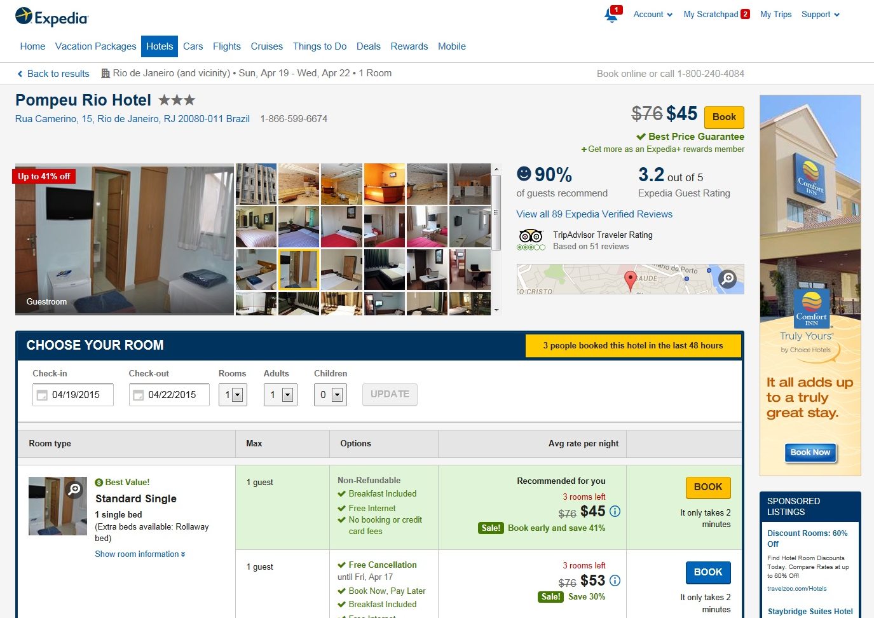

Appendix B—Flight Information

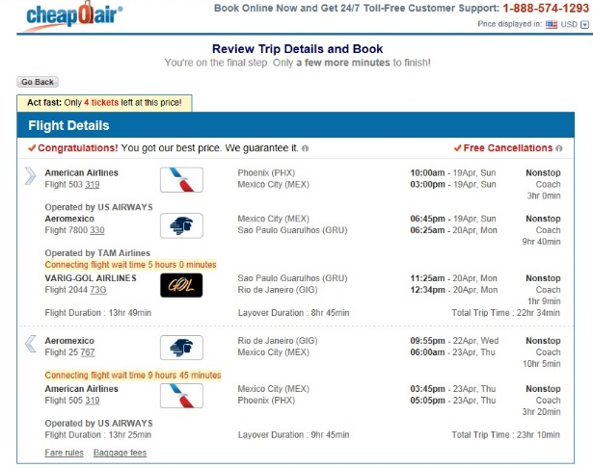

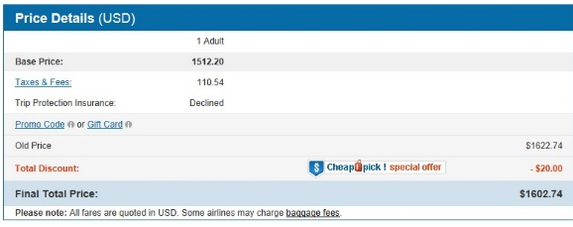
Appendix C—Presentation Outline

- FBLA-Why Should You Join
- What is FBLA?
- Future Business Leaders of America
- FBLA Mission
- Service, Education, and Progress
- Service
- Join other students, help in community, bring people together
- Education
- Learn about business, participate in workshops, increase professionalism
- Progress
- Be innovative, learn new ways to do things, grow as business does
- Goals
- Nine goals
- Explain goals
- Conferences
- Explain what they are
- What can come from them
- Professional Dress
- Suits and business dresses
- Chance to expand wardrobe
- Fun
- Awards
- Activities

Appendix D—Recruitment Ideas

- FBLA Presentation
Go talk to people about FBLA and why it’s so fun, plus how it could help them.
- Social Media
Posting pictures from your FBLA activities and events will show other people how fun it is and encourage them to join.
- Membership Madness
Make it a competition between chapters to see who can recruit the most people throughout the year.
- Open House
Have a day where FBLA members set up a booth or something similar and speak to people about what FBLA is and the benefits.
- College Fairs
While FBLA is not at the college level, setting up at a college fair could target students who are still in high school and give them an idea of what FBLA is.
- Charter Schools
Because they don’t have to follow all of the same rules, many charter schools never hear of FBLA. Going to one and introducing it has the potential to bring in many new members.
- FBLA Field Day
Give interested people the chance to just try out FBLA for a day and show them personally how fun it could be.
- YouTube Video
Make a YouTube video about FBLA and how it helps you.
- Write a Song
Write a song about FBLA and then post it. Songs tend to catch people’s attentions quickly.
- Volunteer Work
When people volunteer their time to help, it gives a great impression of FBLA and what it stands for.

Appendix E—Itinerary

ITINERARY

S. B. Shupe

April 19-23, 2015

Sunday, April 19

10:00 a.m. Depart from Phoenix Airport, American Airlines.

3:00 p.m. Land in Mexico City, layover and lunch.

6:45 p.m. Depart from Mexico City, Aeromexico.

Monday, April 20

6:25 a.m. Land in Sao Paulo, layover and breakfast.

11:25 a.m. Depart from Sao Paulo, VARIG-GOL Airlines

12:34 p.m. Land in Rio de Janeiro, final stop. Stop for lunch.

2:00 p.m. Check into Pompeu Rio Hotel.

4:00 p.m. Visit the Christ the Redeemer statue.

7:00 p.m. Dinner.

9:00 p.m. Back to hotel.

Tuesday, April 21

8:00 a.m. Breakfast on way to meeting.

10:00 a.m. Meeting with students and teachers.

12:00 p.m. Question and answer session with potential advisors.

2:00 p.m. Stop for lunch.

4:00 p.m. Visit Ipanema Beach.

6:00 p.m. Stop for dinner at nicer restaurant.
8:00 p.m. Return to hotel.

Wednesday, April 22

8:00 a.m. Check out of hotel.

9:00 a.m. Stop for cheap breakfast.

11:00 a.m. Visit the Quinta da Boa Vista.

1:00 p.m. Stop for lunch.

2:00 p.m. Visit Tijuca National Park.

5:00 p.m. Stop for early dinner.

7:55 p.m. Go to Rio de Janeiro airport.

9:55 p.m. Depart from Rio de Janeiro, Aeromexico.

Thursday, April 23

6:00 a.m. Land in Mexico City, layover and breakfast.

12:00 p.m. Lunch at airport.

3:45 p.m. Depart from Mexico City, American Airlines.

5:05 p.m. Land in Phoenix Airport.

Appendix F—Brochure



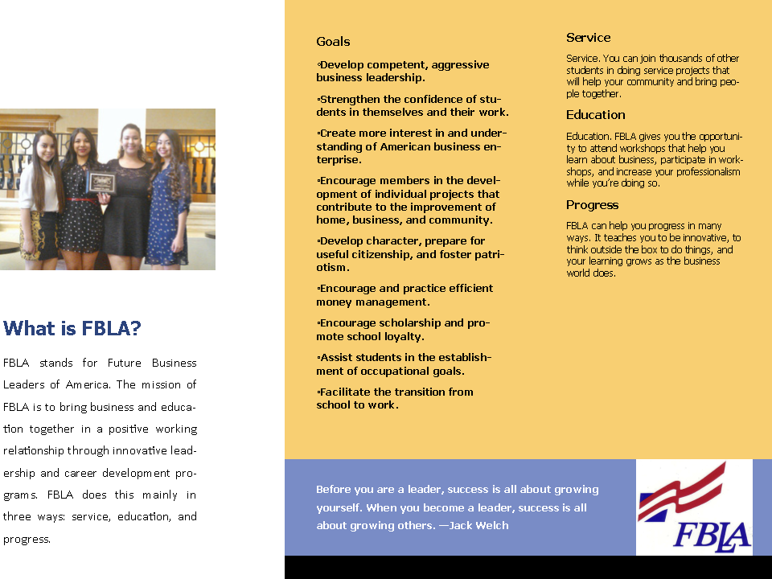

Appendix G—Graphs

Appendix H—Bibliography

2015. Web. 2015 13 January. <cheapoair.com>.
Brazil - Language, Culture, Customs and Etiquette . 2014. Web. 13 January 2015. <http://www.kwintessential.co.uk/resources/global-etiquette/brazil-country-profile.html>.
Brazil Culture. 2014. Web. 3 December 2014. <http://www.brazil.org.za/brazil-culture.html>.
Brazil Currency Exchange. 2013. Web. 30 November 2014. <http://www.rio-de-janeiro-travel-information.com/brazil-currency.html>.
Brazil Demographics Profile 2014. 2014. 25 November 2014. <http://www.indexmundi.com/brazil/demographics_profile.html>.
Brazil Holidays-What Are They & What is There Significance? n.d. Web. 13 January 2015. <http://www.brazilcultureandtravel.com/brazil-holidays.html>.
Brazil’s Main Agricultural Products and Exports. 2015. Web. 13 January 2015. <http://www.4property.uk.com/brazil/main-agricultural-products-and-exports/>.
Brazilian Food. 2014. Web. 30 November 2014. <http://www.foodbycountry.com/Algeria-to-France/Brazil.html>.
Hotel Information. 2015. Web. 13 January 2015. <expedia.com>.
Rio de Janeiro City. 2015. Web. 13 January 2015. <http://www.lonelyplanet.com/brazil/rio-de-janeiro/restaurants/fast-food>.
Structure of Government. n.d. 12 December 2014. <http://countrystudies.us/brazil/85.htm>.
The World Factbook. 23 June 2014. 30 November 2014. <https://www.cia.gov/library/publications/the-world-factbook/geos/br.html>.
Transportation. n.d. 3 December 2014. <http://www.brazil.org.nz/page/transportation.aspx>.
US Passports and International Travel. 14 October 2014. Web. 3 December 2015. <http://travel.state.gov/content/passports/english/country/brazil.html>.
World Population Statistics. 27 February 2014. Web. 13 January 2015. <http://www.worldpopulationstatistics.com/population-of-brazil-2014/>.

